**Looking for participants for a programming study**

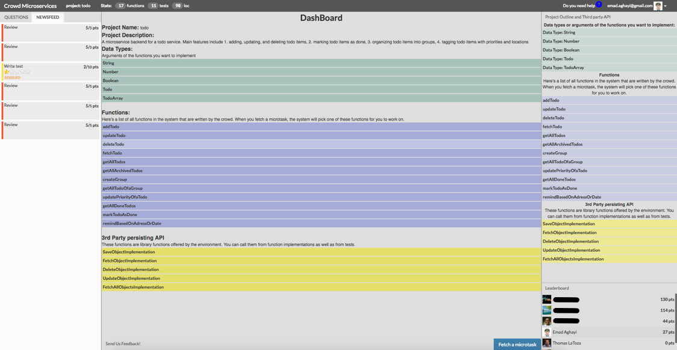

We are conducting a study investigating how developers program in **cloud IDEs**. Participants will be asked to complete a series of simple programming tasks in JavaScript and to answer some questions about their experiences programming in a cloud IDE. The study will be conducted entirely remotely over the Internet.

To participate, you should  
* be comfortable programming in **JavaScript**

As a small token of appreciation, all participants will be paid **$20 / hr**. Slots will last up to 4 hours and are available for

Interested? Send email to **eaghayi@gmu.edu**with  
* a brief (i.e., one line) summary of your software development experience  
* when you're available. We have daytime, evening, and weekend slots available.

About  
The Crowd Programming Study is being conducted as a research study at George Mason University. Our study aims to better understand how developers work using cloud IDEs. The research study is being conducted by Emad Aghayi. Contact eaghayi@gmu.edu for more information or any questions. The IRBNet number for this study is 835511-1.